**Design Templates for Malformation Nation**

10/8/2014

**Image 1**

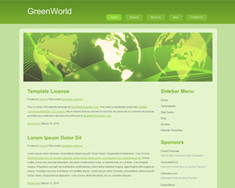

* I like the border style of this site, but wouldn’t want it this green. I’ve been noticing that grey and green go well together in many sites (see Image 2).
* I like the way the active tab becomes a lighter shade as shown in image.
* I image our photo banner could go where they show the global map figure.

**Image 2**

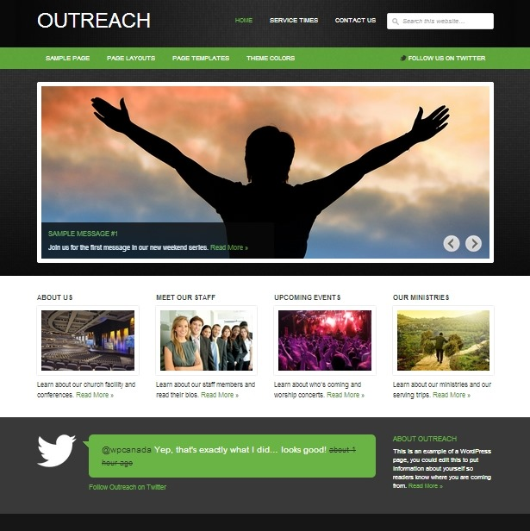

* Again, I like the shades of grey with green.
* Their tab strip looks more professional than in image 1. I image we could do something like this, but incorporating the buffer along the entire site (and not have it broken up as shown in the middle of Image 2).

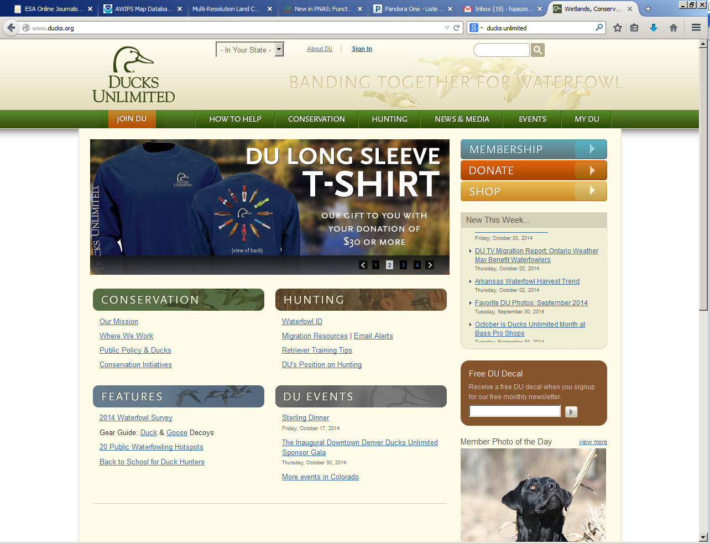<http://www.ducks.org/>

**Image 3**

* Here they have the background border but it is much less noticeable than the above sites. Kind of nice. Notice how they have a nice hardly perceptible image of ducks in the topmost banner. I like that but fear it could make our home page too busy because we will have the photo banner.

**Image 4**

<https://www.flmnh.ufl.edu/>

